Operating system
Paging:
- TLB : Translation look-aside buffer .
- Page table is kept in main memory.
- Address genarated by cpu is divided into;
1. page number – used as an index into page table which conatins base adress of each page in Physical memory/main memory.

2. page size (offset) – combined with base adress to define the physical memory adress that is sent to the main memory .

- cpu generate logical adress which is further converted into physical adress through the page-table.

How virtual memory is considered ?

- If my system is 32bit processor , then my os allocate adresses from 0 to (2^32 -1=4GB) and if i have real 4GB of ram , then there is no virual memory required. If i have 2GB of real ram memory then remaining 2GB are virtual memory .

- If my system is 64bit processor , then my os allocates adresses from 0 to (2^64 -1=4GB * 4GB) and if i have 4GB of ram then remaining are virtual memory size.

What is page-table ?

- Page tables are used to translate the virtual addresses seen by the application into physical addresses used by the hardware to process instructions;[15] such hardware that handles this specific translation is often known as the memory management unit. Each entry in the page table holds a flag indicating whether the corresponding page is in real memory or not. If it is in real memory, the page table entry will contain the real memory address at which the page is stored. When a reference is made to a page by the hardware, if the page table entry for the page indicates that it is not currently in real memory, the hardware raises a page fault exception, invoking the paging supervisor component of the operating system.
- Systems can have one page table for the whole system, separate page tables for each application and segment, a tree of page tables for large segments or some combination of these. If there is only one page table, different applications running at the same time use different parts of a single range of virtual addresses. If there are multiple page or segment tables, there are multiple virtual address spaces and concurrent applications with separate page tables redirect to different real addresses.

What is page Fault ?
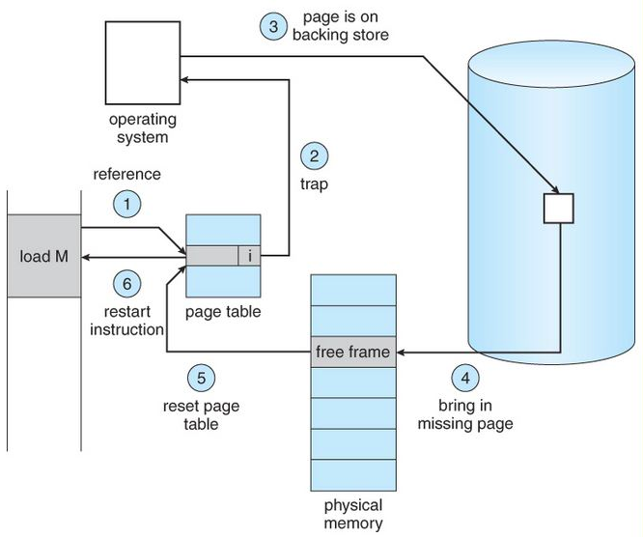
- A page fault occurs when a program attempts to access data or code that is in its address space, but is not currently located in the system RAM. So when page fault occurs then following sequence of events happens :
1.Determine the location of the data on disk.
- Obtain an empty page frame in RAM to use as a container for the data.
- Load the requested data into the available page frame.
- Update the page table to refer to the new page frame.
- Return control to the program, transparently retrying the instruction that caused the page fault.

What is TLB(Translation lookaside buffer) ?

- The CPU's memory management unit (MMU) stores a cache of recently used mappings from the operating system's page table. This is called the translation lookaside buffer (TLB), which is an associative cache.[3]
When a virtual address needs to be translated into a physical address, the TLB is searched first. If a match is found (a TLB hit), the physical address is returned and memory access can continue. However, if there is no match (called a TLB miss), the memory management unit, or the operating system TLB miss handler, will typically look up the address mapping in the page table to see whether a mapping exists (a page walk). If one exists, it is written back to the TLB (this must be done, as the hardware accesses memory through the TLB in a virtual memory system), and the faulting instruction is restarted (this may happen in parallel as well). This subsequent translation will find a TLB hit, and the memory access will continue.
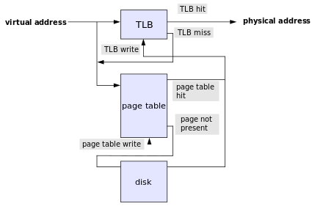

Translation Fail :
- The page table lookup may fail for two reasons:
- The lookup may fail if there is no translation available for the virtual address, meaning that virtual address is invalid. This will typically occur because of a programming error, and the operating system must take some action to deal with the problem. On modern operating systems, it will cause a segmentation fault signal being sent to the offending program.
- The lookup may also fail if the page is currently not resident in physical memory. This will occur if the requested page has been moved out of physical memory to make room for another page. In this case the page is paged out to a secondary store located on a medium such as a hard disk drive (this secondary store, or "backing store", is often called a "swap partition" if it is a disk partition, or a swap file, "swapfile" or "page file" if it is a file). When this happens the page needs to be taken from disk and put back into physical memory. A similar mechanism is used for memory-mapped files, which are mapped to virtual memory and loaded to physical memory on demand.
When physical memory is not full this is a simple operation; the page is written back into physical memory, the page table and TLB are updated, and the instruction is restarted. However, when physical memory is full, one or more pages in physical memory will need to be paged out to make room for the requested page. The page table needs to be updated to mark that the pages that were previously in physical memory are no longer there, and to mark that the page that was on disk is now in physical memory. The TLB also needs to be updated, including removal of the paged-out page from it, and the instruction restarted. Which page to page out is the subject of page replacement algorithms.

INTERRUPT :
- Interrupts enable hardware to signal to the processor.
- The processor receives the interrupt and signals the operating system to enable the operating system to respond to the new data.
- The kernel can be interrupted at any time to process interrupts.
- An interrupt is physically produced by electronic signals originating from hardware devices .

How interupts are handeld ?

- H/w devices ----> i/p pins on interrupt controller (pic:programable interupt controller is a chip that multiplexes multiple interrupt lines into a single line to the processor ) ----> processor(it detects the signal and interrupts its current execution to handle the interrupt) ----> notify to OS that interrupt has occured.This enables the operating system to differentiate between interrupts and to know which hardware device caused which interrupt. In turn, the operating system can service each interrupt with its corresponding handler.

- Different devices can be associated with different interrupts bymeans of a unique value associated with each interrupt.This interrupt value is called IRQ(Interrupt Request) .
- The important notion is that a specific interrupt is associated with a
specific device, and the kernel knows this.The hardware then issues interrupts to get the kernel’s attention: “Hey, I have new key presses waiting! Read and process these bad boys “ .

INTERRUPT HANDLER :
- The function the kernel runs in response to a specific interrupt is called an interrupt handler or interrupt service routine (ISR).
- The interrupt handler for a device is part of the device’s driver—the kernel code that manages the device.

TOP halves and BOTTOM halves :
- The processing of interrup is devided into two parts/halves,
Top Halves :
- interrupt handler is the top half.
- The top half is run immediately upon receipt of the interrupt and performs only the work that is time-critical, such as acknowledging receipt of the interrupt or resetting the hardware.Work that can be performed later is deferred until the bottom halves .
- Bottom half runs in the future, at a more convenient time, with all interrupts enabled.
Example of top halves :
- when network card recieves data packets from the network , they need to alret the kernel of their availabilty . They want and need to do this immediatly , to optimize the network throughput and latency and avoid timeouts . Thus they imediatly issue an interrupt : “Hey kernle,i have some fresh packets “! Kernle responds by executing the network card’s registered interrupt .
- The interrupts runs and acknowledge the hardware ,copies the networking packets into main memory and readies the network card for more packets .
- These jobs are generally hardware specific .
- Kernel generally needs to copy network packets immediatly from the network data buffer to main memory as data buffer is fixed and miniscule(very small) as compared to main memory.
- If kernel will do delay in copying packets can result buffer overrun,with incomming packets overwhelming the networking card’s buffer and thus packets being dropped .
- After the networking data is safely in the main memory, the interrupt’s job is done, and it can return the control of the system to whatever code was interrupted when the interrupt was generated.The rest of the processing and handling of the packets occurs later, in the bottom half.

Registering interrupt Handler :
- Interrupt handler are responsibilty of driver managing hardware .
- Each device has one associated driver,if that device uses interrupts ,
then that driver should register one interrupt handler .
- Driver can register an interrupt handler and enable an interrupt line for handling with the function request_irq() .
- For allocating interrupt line : int request_irq(unsigned int irq, irq_handler_t handler , unsigned long flags , const char *name,void *dev)
- irq :- specifies the interrupt number to allocate
- handler :- is a function pointer to the actual interrupt handler
- that services this interrupt.This function is invoked whenever the operating system receives the interrupt.
Ex : typedef irqreturn_t (*irq_handler_t)(int, void *);
- flag : zero or bit mask ( IRQF_DISABLED , IRQF_TIMER , IRQF_SHARED , IRQF_SAMPLE_RANDOM)
- name :- devices associated with interrupt
- dev : shared interrupt lines

Process tables :
- Operating system maintains the track of the state of processes (running,waitng,ready) is known as process table. Inside the table, every process is listed along with the resources using by process and the current state of process.

